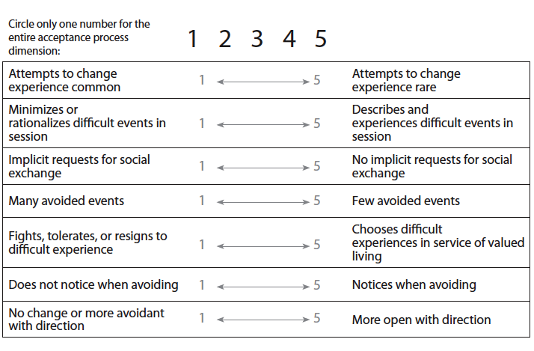
Therapist
- What are some topics and/or experiences I avoid with this client?

- To what degree do I shy away from experiential work and talk about what’s comfortable?

- What do I do to avoid feeling uncomfortable in session? [Ex: over/under preparation, expert role (e.g., explain theory)]

- What have the consequences of these choices been?

Client

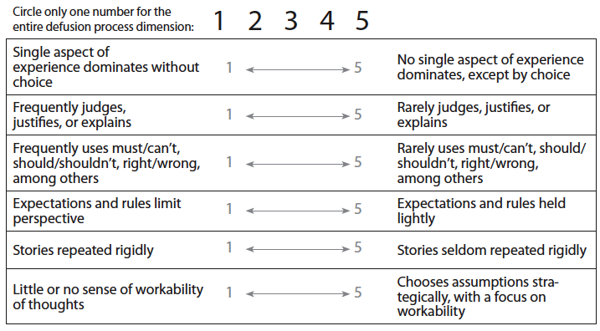
Therapist

- What thoughts do I struggle with when I’m with this client? [Ex: they’re “hopeless,” I’m not competent]

- What is typically going on in therapy when these thoughts come up?

- What do I believe must change before this client improves?

- When do I believe I know what’s “best” for this client (e.g., what they should do or not do)?

Client

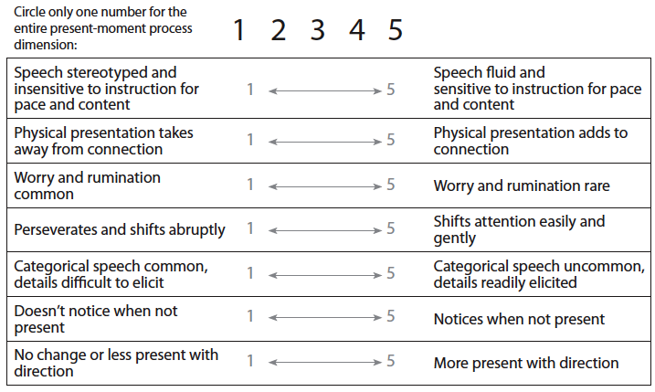

Therapist

- When do I disengage or zone out during session with this client?

- When do I passively listen to the client or find myself waiting for the session to end?

- How might these moments affect this client?

- What might it look like if I could remain present during these moments? How might my presence be of service to this client?

Client

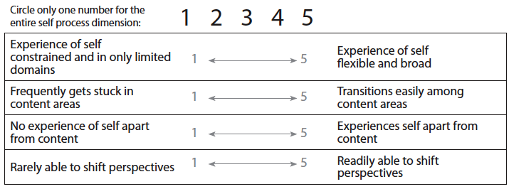

Therapist

- What stories do I tell about myself and about my client?

- How do these stories might affect our work together?

- How lightly do I hold these stories?

- How deeply do I feel this client’s suffering and understand their hopes and dreams?

Client

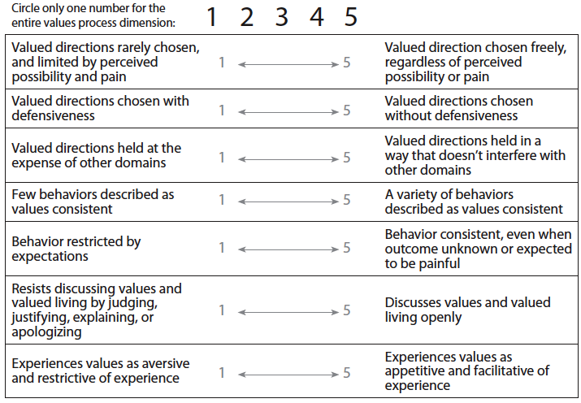

Therapist

- What qualities do I want to bring to sessions with this client?

- What comes up for me as I write down those words, as I claim this possibility?

- What might it mean both to me and to my client if I could act to further this value?

- To what extent am I the therapist I want to be with this client?

Client

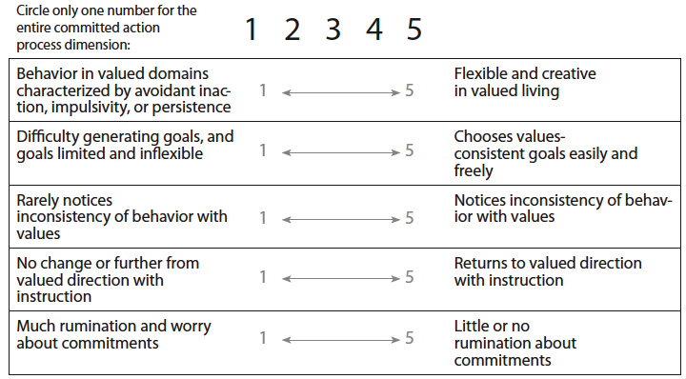

Therapist

- What kind of actions would take me towards being the kind of therapist I want to be with this client?

- When do I notice myself turning away from these commitments?

- Can I gently return to them? What would that look like for me?

- To what extent do I find myself actively working toward the client’s goals?

Client

